[e-commerce app with .Net Core and Angular](https://kumaran.udemy.com/course/learn-to-build-an-e-commerce-app-with-net-core-and-angular/)

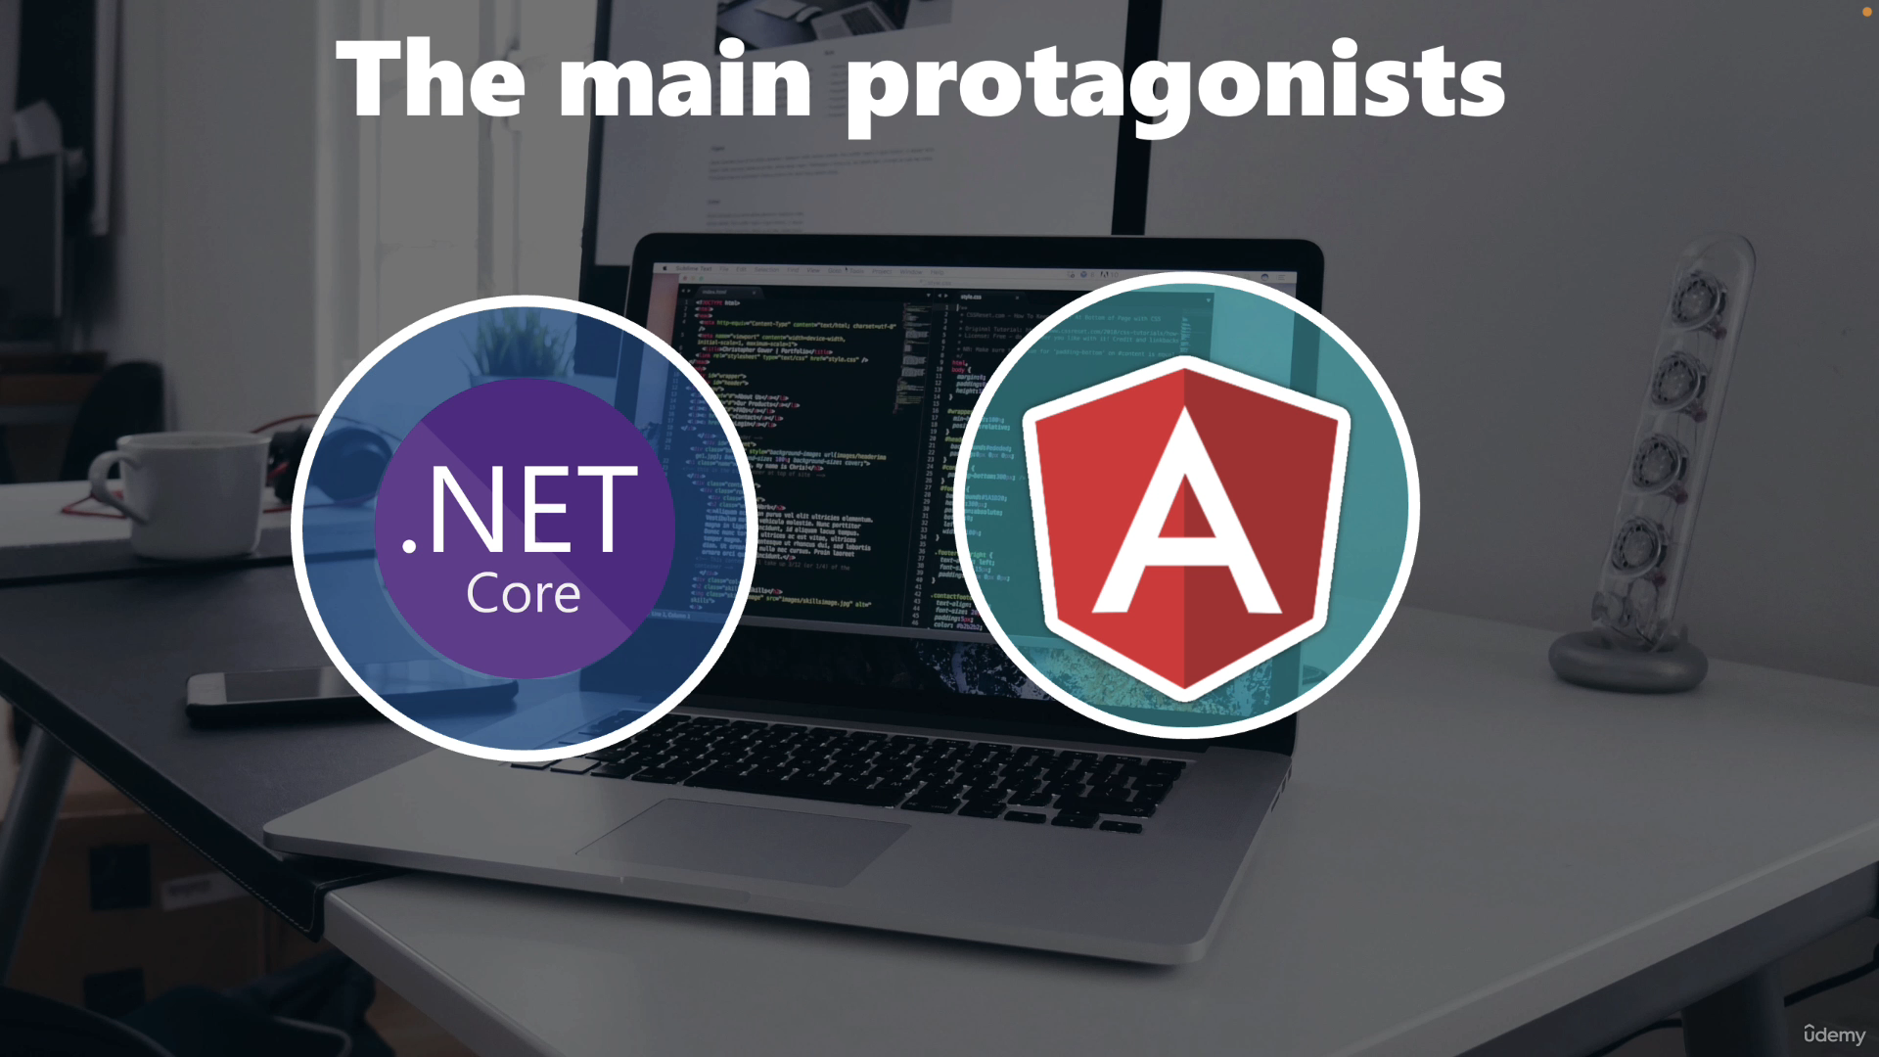

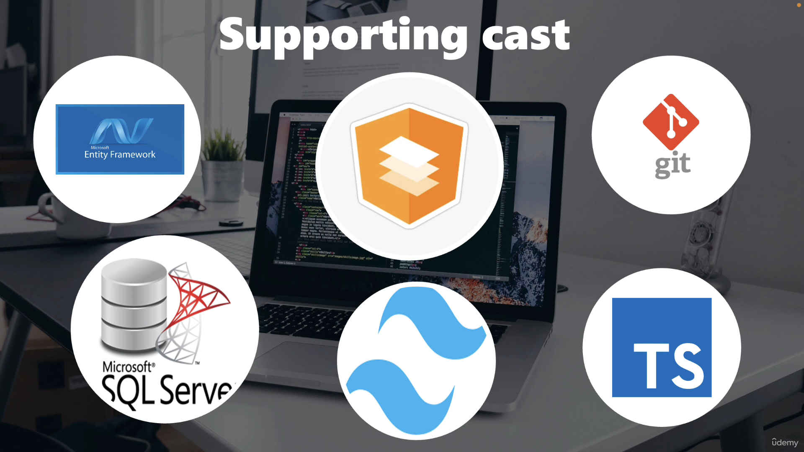

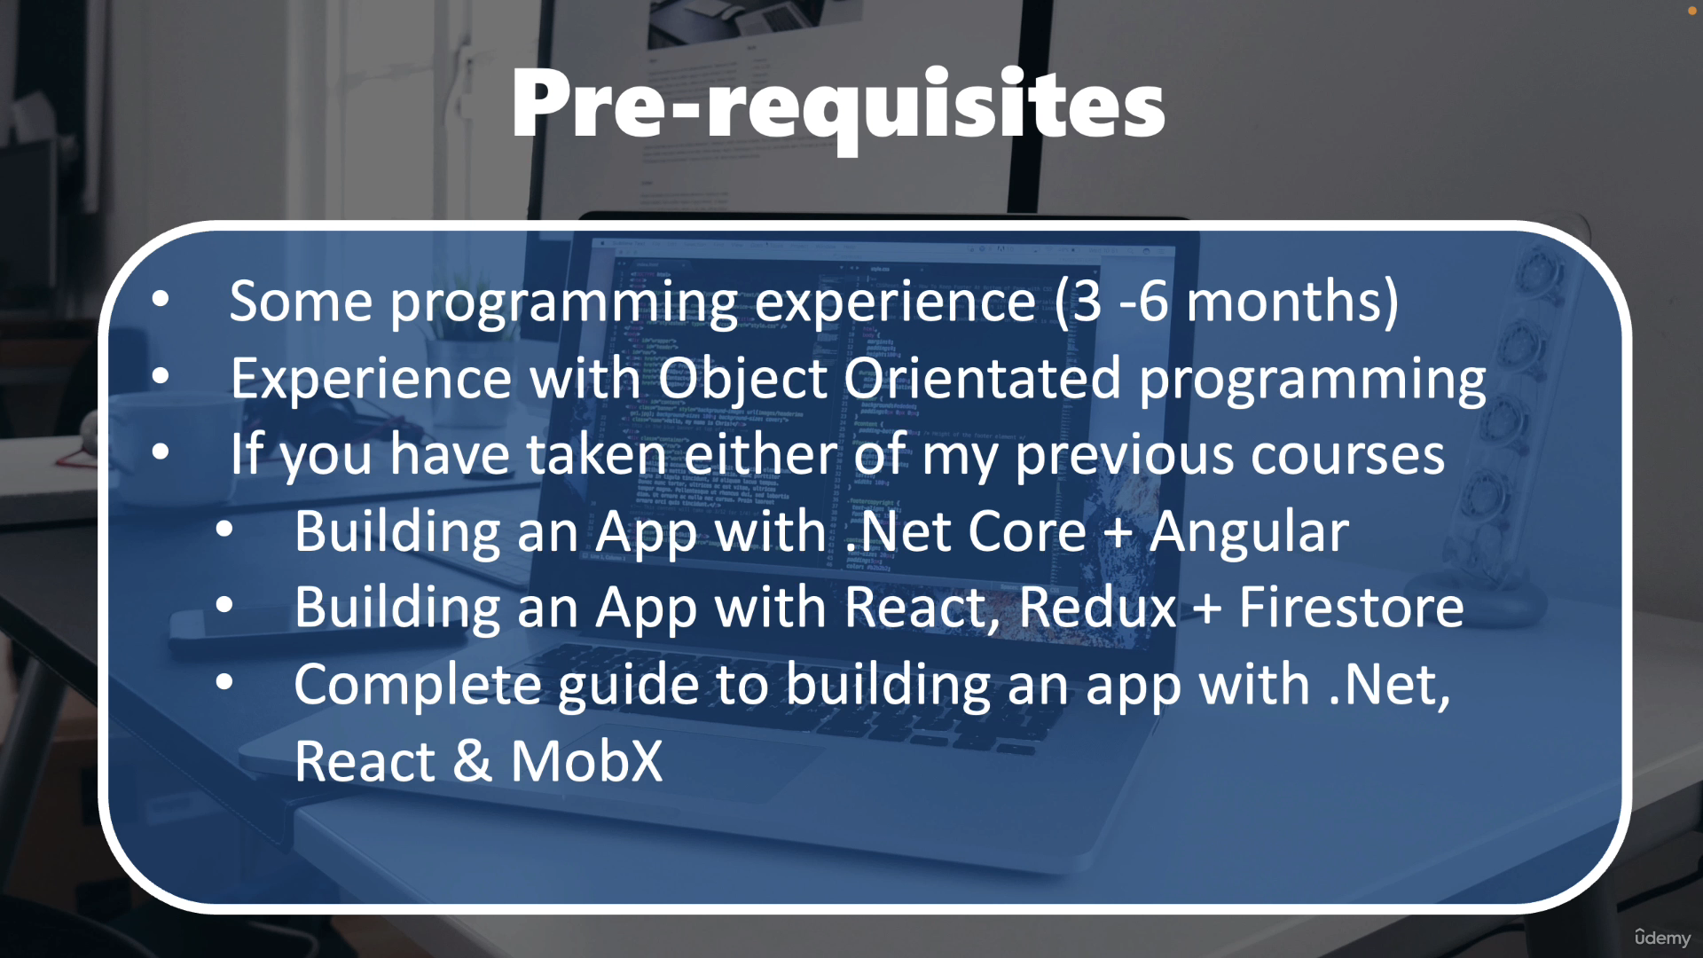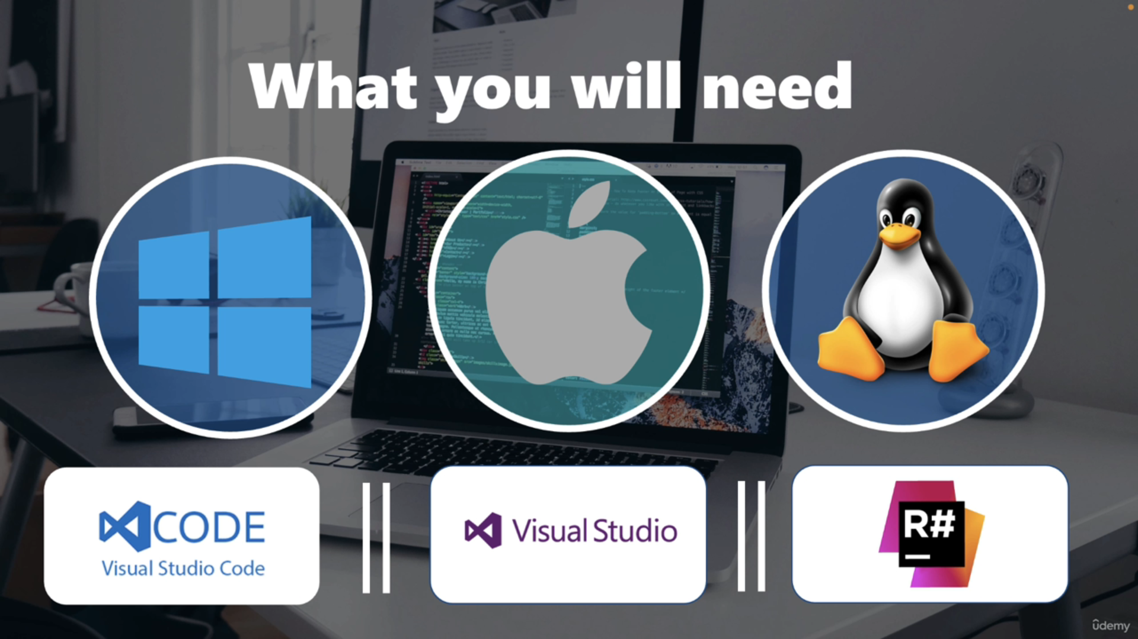

* Vs code / VS
* Docker
* Git
* Postman
* SQLServer

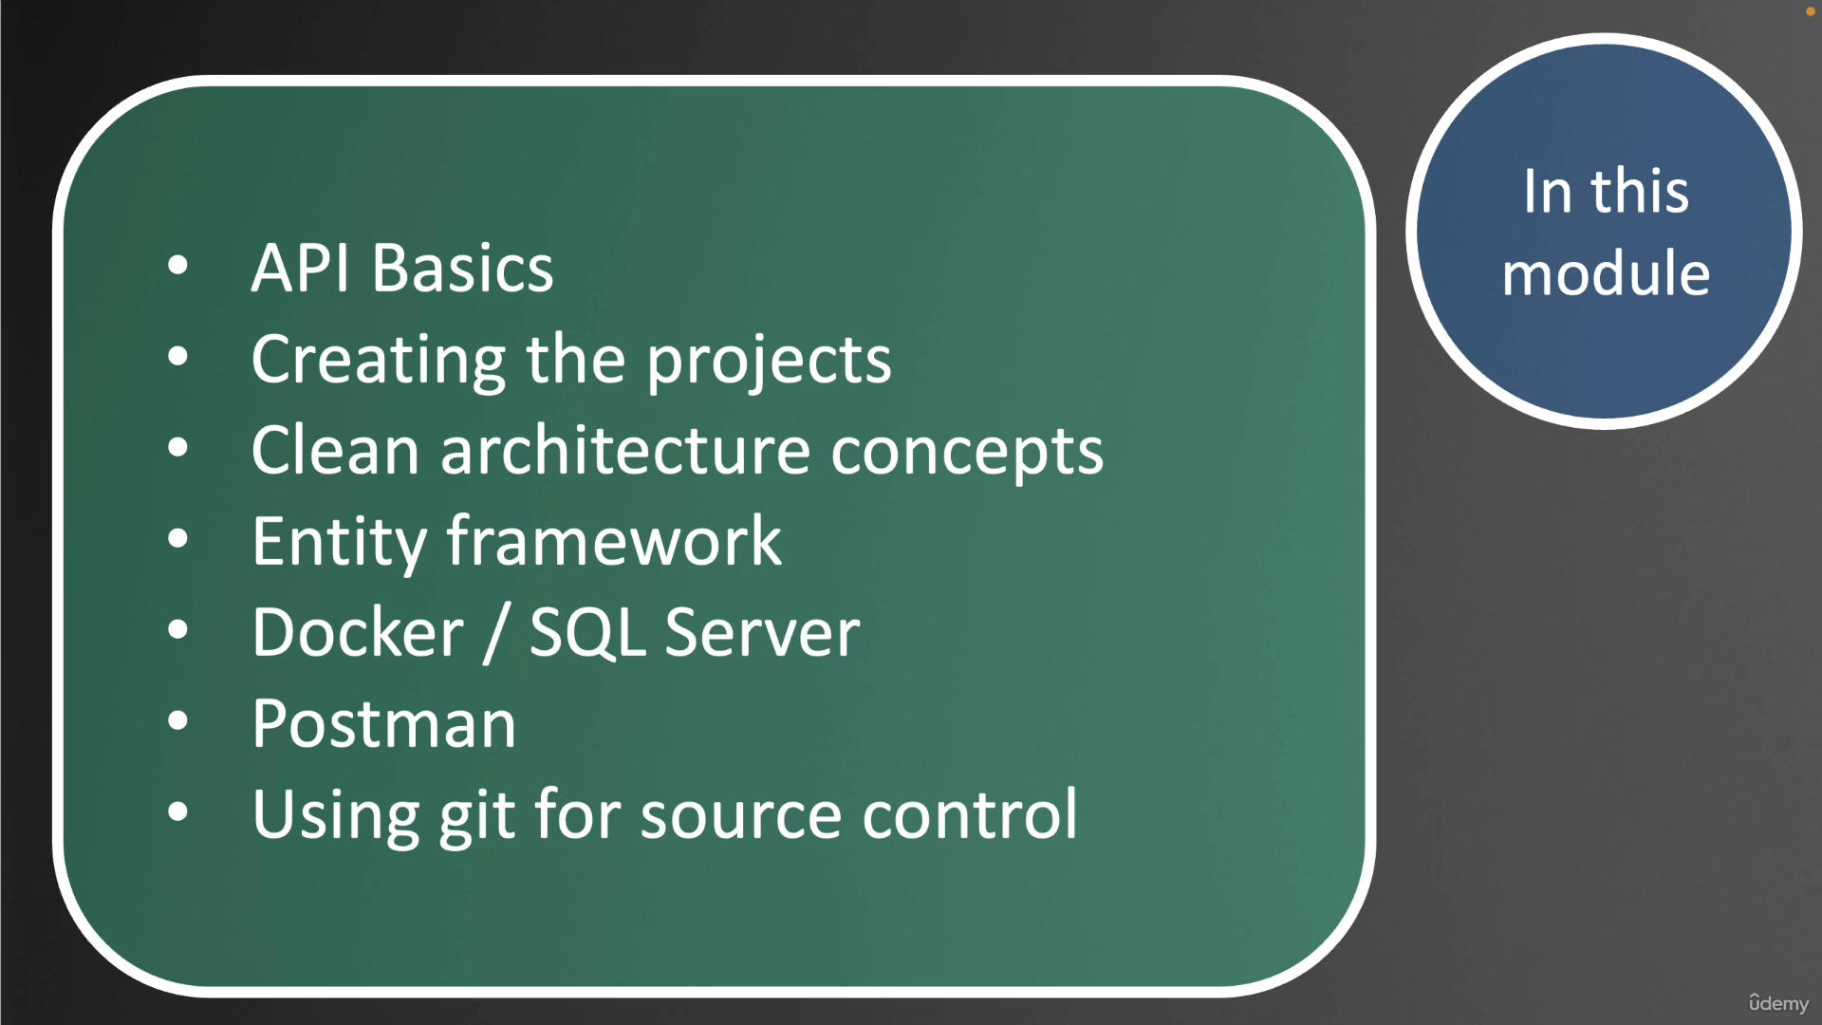

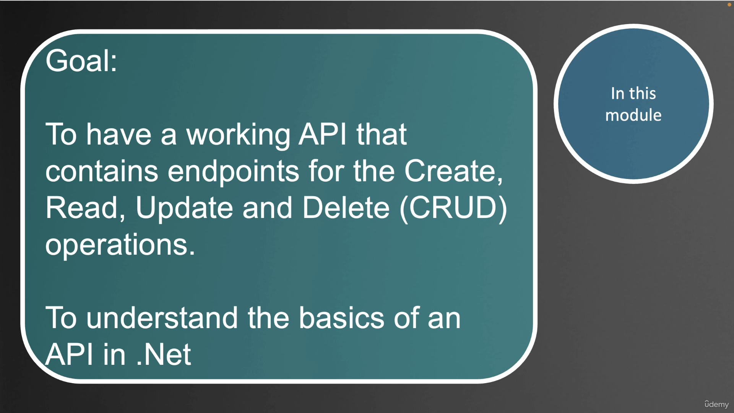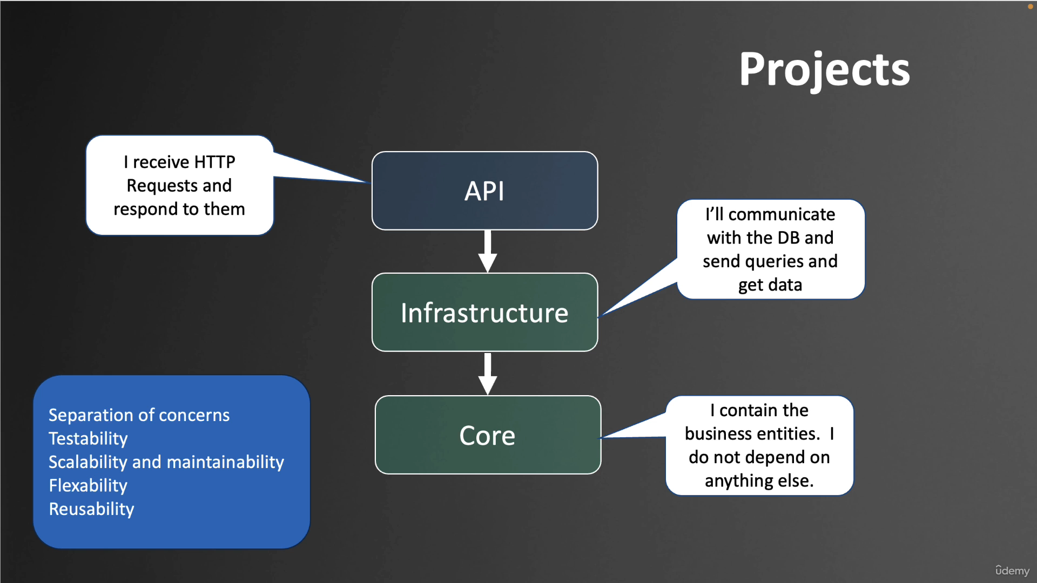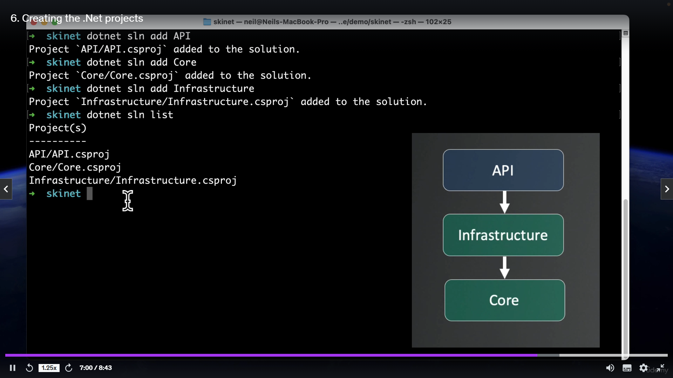

dotnet tool install --global dotnet-ef --version 8.0.8

"ConnectionStrings": {

"DefaultConnection": "Server=lochost;Database=skinet;Trusted_Connection=True;TrustServerCertificate=True"

}

dotnet ef migrations add InitialCreate -s API -p Infrastructure

namespace Infrastructure.Config

{

public class ProductConfiguration : IEntityTypeConfiguration<Product>

{

public void Configure(EntityTypeBuilder<Product> builder)

{

builder.Property(x => x.Price).HasColumnType("decimal(18,2");

builder.Property(x => x.Name).IsRequired();

}

}

}

public class StoreContext : DbContext

{

public StoreContext(DbContextOptions options): base(options) { }

public DbSet<Product> Products { get; set; }

protected override void OnModelCreating(ModelBuilder modelBuilder)

{

base.OnModelCreating(modelBuilder);

modelBuilder.ApplyConfigurationsFromAssembly(typeof(ProductConfiguration).Assembly);

}

}

SEED Data

namespace Infrastructure.Data

{

public class StoreContextSeed

{

public static async Task SeedAsync(StoreContext context)

{

if (!context.Products.Any())

{

var productsData = await File.ReadAllTextAsync("../Infrastructure/Data/SeedData/products.json");

var products = JsonSerializer.Deserialize<List<Product>>(productsData);

if (products == null) return;

context.Products.AddRange(products);

await context.SaveChangesAsync();

}

}

}

}

**Program.cs**

app.MapControllers();

try

{

using var scope = app.Services.CreateScope();

var services = scope.ServiceProvider;

var context = services.GetRequiredService<StoreContext>();

await context.Database.MigrateAsync();

await StoreContextSeed.SeedAsync(context);

}

catch (Exception ex)

{

Console.WriteLine(ex);

throw;

}

app.Run();

namespace Core.Interfaces

{

public interface IGenericRepository<T> where T : BaseEntity

{

Task<T?> GetByIdAsync(int id);

Task<IReadOnlyList<T>> ListAllAsync();

void Add(T entity);

void Update(T entity);

void Remove(T entity);

Task<bool> SaveAllAsync();

bool Exists(int id);

}

}

namespace Infrastructure.Data

{

public class GenericRepository<T>(StoreContext context) : IGenericRepository<T> where T : BaseEntity

{

public void Add(T entity)

{

context.Set<T>().Add(entity);

}

public bool Exists(int id)

{

return context.Set<T>().Any(x=>x.Id == id);

}

public async Task<T?> GetByIdAsync(int id)

{

return await context.Set<T>().FindAsync(id);

}

public async Task<IReadOnlyList<T>> ListAllAsync()

{

return await context.Set<T>().ToListAsync();

}

public void Remove(T entity)

{

context.Set<T>().Remove(entity);

}

public async Task<bool> SaveAllAsync()

{

return await context.SaveChangesAsync() > 0;

}

public void Update(T entity)

{

context.Set<T>().Attach(entity);

context.Entry(entity).State = EntityState.Modified;

}

}

}

namespace Core.Interfaces

{

public interface ISpecification<T>

{

Expression<Func<T, bool>> Criteria { get;}

}

}

namespace Core.Specification

{

public class BaseSpecification<T>(Expression<Func<T,bool>> _criteria) : ISpecification<T>

{

public Expression<Func<T, bool>> Criteria => _criteria;

}

}

namespace Infrastructure.Data

{

public class SpecificationEvaluator<T> where T : BaseEntity

{

public static IQueryable<T> GetQuery(IQueryable<T> query, ISpecification<T> spec)

{

if (spec.Criteria != null)

{

query = query.Where(spec.Criteria); // x => x.Brand == brand

}

return query;

}

}

}

namespace Core.Interfaces

{

public interface IGenericRepository<T> where T : BaseEntity

{

Task<T?> GetByIdAsync(int id);

Task<IReadOnlyList<T>> ListAllAsync();

**Task<T?> GetEntityWithSpec(ISpecification<T> spec);**

**Task<IReadOnlyList<T>> ListAsync(ISpecification<T> spec);**

void Add(T entity);

void Update(T entity);

void Remove(T entity);

Task<bool> SaveAllAsync();

bool Exists(int id);

}

}

public class GenericRepository<T>(StoreContext context) : IGenericRepository<T> where T : BaseEntity

{

public async Task<T?> GetEntityWithSpec(ISpecification<T> spec)

{

return await ApplySpecification(spec).FirstOrDefaultAsync();

}

public async Task<IReadOnlyList<T>> ListAsync(ISpecification<T> spec)

{

return await ApplySpecification(spec).ToListAsync();

}

private IQueryable<T> ApplySpecification (ISpecification<T> spec)

{

return SpecificationEvaluator<T>.GetQuery(context.Set<T>().AsQueryable(), spec);

}

}

namespace Core.Specification

{

public class BaseSpecification<T>(Expression<Func<T,bool>> _criteria) : ISpecification<T>

{

protected BaseSpecification() : this(null) { }

public Expression<Func<T, bool>>? Criteria => _criteria;

}

}

namespace Core.Specification

{

public class ProductSpecification : BaseSpecification<Product>

{

public ProductSpecification(string? brand,string? type) : base(x =>

(string.IsNullOrWhiteSpace(brand) || x.Brand == brand) &&

(string.IsNullOrWhiteSpace(type) || x.Type == type)

)

{

}

}

}

[HttpGet]

public async Task<ActionResult<IReadOnlyList<Product>>> GetProducts(string? brand,

string? type,string? sort)

{

var spec = new ProductSpecification(brand, type);

var products = await repo.ListAsync(spec);

return Ok(products);

}

namespace Core.Interfaces

{

public interface ISpecification<T>

{

Expression<Func<T, bool>> Criteria { get;}

**Expression<Func<T,object>>? OrderBy { get;}**

**Expression<Func<T,object>>? OrderByDescending { get;}**

}

}

namespace Core.Specification

{

public class BaseSpecification<T>(Expression<Func<T, bool>> _criteria) : ISpecification<T>

{

protected BaseSpecification() : this(null) { }

public Expression<Func<T, bool>>? Criteria => _criteria;

**public Expression<Func<T, object>>? OrderBy { get; private set; }**

**public Expression<Func<T, object>>? OrderByDescending { get; private set; }**

**protected void AddOrderBy(Expression<Func<T, object>> orderByExpression)**

**{**

**OrderBy = orderByExpression;**

**}**

**protected void AddOrderByDescending(Expression<Func<T, object>> orderByDescendingExpression)**

**{**

**OrderBy = orderByDescendingExpression;**

**}**

}

}

namespace Infrastructure.Data

{

public class SpecificationEvaluator<T> where T : BaseEntity

{

public static IQueryable<T> GetQuery(IQueryable<T> query, ISpecification<T> spec)

{

if (spec.Criteria != null)

{

query = query.Where(spec.Criteria); // x => x.Brand == brand

}

if (spec.OrderBy != null) {

query = query.OrderBy(spec.OrderBy);

}

if(spec.OrderByDescending != null)

{

query = query.OrderByDescending(spec.OrderByDescending);

}

return query;

}

}

}

namespace Core.Specification

{

public class ProductSpecification : BaseSpecification<Product>

{

public ProductSpecification(string? brand,string? type,string? sort) : base(x =>

(string.IsNullOrWhiteSpace(brand) || x.Brand == brand) &&

(string.IsNullOrWhiteSpace(type) || x.Type == type)

)

{

switch (sort)

{

case "priceAsc":

AddOrderBy(x=>x.Price);

break;

case "priceDesc":

AddOrderByDescending(x=>x.Price);

break;

default:

AddOrderBy(x=>x.Name);

break;

}

}

}

}

[HttpGet]

public async Task<ActionResult<IReadOnlyList<Product>>> GetProducts(string? brand,

string? type,string? sort)

{

var spec = new ProductSpecification(brand, type,**sort**);

var products = await repo.ListAsync(spec);

return Ok(products);

}

namespace Core.Interfaces

public interface ISpecification<T,TResult> : ISpecification<T>

{

Expression<Func<T, TResult>>? Select { get; }

}

namespace Core.Specification

public class BaseSpecification<T, TResult>(Expression<Func<T, bool>> criteria)

: BaseSpecification<T>(criteria), ISpecification<T, TResult>

{

public Expression<Func<T, TResult>>? Select { get; private set; }

protected void AddSelect(Expression<Func<T, TResult>> selectExpression)

{

Select = selectExpression;

}

}

namespace Infrastructure.Data

public static IQueryable<TResult> GetQuery<TSpec,TResult>(IQueryable<T> query, ISpecification<T,TResult> spec)

{

if (spec.Criteria != null)

{

query = query.Where(spec.Criteria); // x => x.Brand == brand

}

if (spec.OrderBy != null)

{

query = query.OrderBy(spec.OrderBy);

}

if (spec.OrderByDescending != null)

{

query = query.OrderByDescending(spec.OrderByDescending);

}

var selectQuery = query as IQueryable<TResult>;

if (spec.Select != null) {

selectQuery = query.Select(spec.Select);

}

return selectQuery ?? query.Cast<TResult>();

}

namespace Core.Interfaces

Task<TResult?> GetEntityWithSpec<TResult>(ISpecification<T,TResult> spec);

Task<IReadOnlyList<TResult>> ListAsync<TResult>(ISpecification<T,TResult> spec);

namespace Infrastructure.Data

public async Task<TResult?> GetEntityWithSpec<TResult>(ISpecification<T, TResult> spec)

{

return await ApplySpecification(spec).FirstOrDefaultAsync();

}

public async Task<IReadOnlyList<TResult>> ListAsync<TResult>(ISpecification<T, TResult> spec)

{

return await ApplySpecification(spec).ToListAsync();

}

private IQueryable<TResult> ApplySpecification<TResult>(ISpecification<T,TResult> spec)

{

return SpecificationEvaluator<T>.GetQuery<T,TResult>(context.Set<T>().AsQueryable(), spec);

}

namespace Core.Interfaces

bool IsDistinct { get; }

namespace Core.Specification

public bool IsDistinct { get; private set; }

protected void ApplyDistinct()

{

IsDistinct = true;

}

namespace Infrastructure.Data

public class SpecificationEvaluator<T> where T : BaseEntity

if (spec.IsDistinct)

{

query = query.Distinct();

}

if (spec.IsDistinct)

{

selectQuery = selectQuery?.Distinct();

}

namespace Core.Specification

namespace Core.Specification

{

public class BrandListSpecification : BaseSpecification<Product,string>

{

public BrandListSpecification()

{

AddSelect(x => x.Brand);

ApplyDistinct();

}

}

}

BaseSpecification

public class BaseSpecification<T, TResult>(Expression<Func<T, bool>> criteria)

: BaseSpecification<T>(criteria), ISpecification<T, TResult>

{

**protected BaseSpecification() : this(null!) { }**

public Expression<Func<T, TResult>>? Select { get; private set; }

protected void AddSelect(Expression<Func<T, TResult>> selectExpression)

{

Select = selectExpression;

}

}

TypeListSpecification

namespace Core.Specification

{

public class TypeListSpecification : BaseSpecification<Product, string>

{

public TypeListSpecification()

{

AddSelect(x=>x.Type);

ApplyDistinct();

}

}

}

**Section 5 – Sorting,Filtering,Searching and Pagination**

Paginaion - Performance

* Parameters passed by query string :

/api/products?pageNumber=2&pageSize=5

* Page size should be limited
* We should always page results

Deferred Execution

* Query commands are stored in a variable
* Execution of the query is deferred
* IQueryable<T> creates an expression tree
* Execution :
  + ToList(), ToArray(), ToDictionary()
  + Count() or other singleton queries

namespace Core.Specification

{

public class ProductSpecParams

{

private List<string> _brands = [];

public List<string> Brands

{

get => _brands;

set

{

_brands = value.SelectMany(x => x.Split(',',StringSplitOptions.RemoveEmptyEntries)).ToList();

}

}

private List<string> _types = [];

public List<string> Types

{

get => _types;

set

{

_types = value.SelectMany(x => x.Split(',', StringSplitOptions.RemoveEmptyEntries)).ToList();

}

}

public string? sort { get; set; }

}

}

namespace Core.Specification

{

public class ProductSpecification : BaseSpecification<Product>

{

public ProductSpecification(ProductSpecParams specParams) : base(x =>

(specParams.Brands.Count == 0 || specParams.Brands.Contains(x.Brand)) &&

(specParams.Types.Count == 0 || specParams.Types.Contains(x.Type))

)

{

switch (specParams.sort)

{

case "priceAsc":

AddOrderBy(x=>x.Price);

break;

case "priceDesc":

AddOrderByDescending(x=>x.Price);

break;

default:

AddOrderBy(x=>x.Name);

break;

}

}

}

}

namespace API.Controllers

[HttpGet]

public async Task<ActionResult<IReadOnlyList<Product>>> GetProducts([FromQuery]ProductSpecParams specParams)

{

var spec = new ProductSpecification(specParams);

var products = await repo.ListAsync(spec);

return Ok(products);

}

Adding Pagination

namespace Core.Interfaces

{

public interface ISpecification<T>

{

int Take { get; }

int Skip { get; }

bool IsPagingEnabled { get; }

}

}

namespace Core.Specification

{

public class BaseSpecification<T>(Expression<Func<T, bool>> _criteria) : ISpecification<T>

{

public int Take { get; private set; }

public int Skip { get; private set; }

public bool IsPagingEnabled { get; private set; }

protected void ApplyPaging(int skip,int take)

{

Skip = skip;

Take = take;

IsPagingEnabled = true;

}

}

}

namespace Infrastructure.Data

SpecificationEvaluator

if (spec.IsPagingEnabled) {

query = query.Skip(spec.Skip).Take(spec.Take);

}

if (spec.IsPagingEnabled)

{

selectQuery = selectQuery?.Skip(spec.Skip).Take(spec.Take);

}

namespace Core.Specification

{

public class ProductSpecParams

{

private const int MaxPageSize = 50;

public int PageIndex { get; set; } = 1;

private int _pageSize = 6;

public int PageSize

{

get => _pageSize;

set => _pageSize = (value > MaxPageSize) ? MaxPageSize : value;

}

}

}

namespace Core.Specification

{

public class ProductSpecification : BaseSpecification<Product>

{

public ProductSpecification(ProductSpecParams specParams) : base(x =>

(specParams.Brands.Count == 0 || specParams.Brands.Contains(x.Brand)) &&

(specParams.Types.Count == 0 || specParams.Types.Contains(x.Type))

)

{

ApplyPaging(specParams.PageSize * (specParams.PageIndex - 1),specParams.PageSize);

}

}

}

namespace API.RequestHelpers

{

public class Pagination <T>(int pageIndex, int pageSize, int count, IReadOnlyList<T> data)

{

public int PageIndex { get; set; } = pageIndex;

public int PageSize { get; set; } = pageSize;

public int Count { get; set; } = count;

public IReadOnlyList<T> Data { get; set; } = data;

}

}

namespace Core.Interfaces

{

public interface IGenericRepository<T> where T : BaseEntity

{

Task<int> CountAsync(ISpecification<T> spec);

}

}

namespace Core.Interfaces

{

public interface ISpecification<T>

{

IQueryable<T> ApplyCriteria(IQueryable<T> query);

}

}

namespace Core.Specification

{

public class BaseSpecification<T>(Expression<Func<T, bool>> _criteria) : ISpecification<T>

{

public IQueryable<T> ApplyCriteria(IQueryable<T> query)

{

if(Criteria != null)

{

query = query.Where(Criteria);

}

return query;

}

}

}

namespace Infrastructure.Data

{

public class GenericRepository<T>(StoreContext context) : IGenericRepository<T> where T : BaseEntity

{

public async Task<int> CountAsync(ISpecification<T> spec)

{

var query = context.Set<T>().AsQueryable();

query = spec.ApplyCriteria(query);

return await query.CountAsync();

}

**}**

**}**

[HttpGet]

public async Task<ActionResult<IReadOnlyList<Product>>> GetProducts([FromQuery]ProductSpecParams specParams)

{

var spec = new ProductSpecification(specParams);

var products = await repo.ListAsync(spec);

var count = await repo.CountAsync(spec);

var pagination = new Pagination<Product>(specParams.PageIndex,specParams.PageSize,count,products);

return Ok(pagination);

}

**Create API Base Controller**

namespace API.Controllers

{

[Route("api/[controller]")]

[ApiController]

public class BaseApiController : ControllerBase

{

protected async Task<ActionResult> CreatePagedResult<T>(IGenericRepository<T> repo,

ISpecification<T> spec, int pageIndex,int pageSize) where T : BaseEntity

{

var items = await repo.ListAsync(spec);

var count = await repo.CountAsync(spec);

var pagination = new Pagination<T>(pageIndex, pageSize, count, items);

return Ok(pagination);

}

}

}

namespace API.Controllers

[HttpGet]

public async Task<ActionResult<IReadOnlyList<Product>>> GetProducts([FromQuery]ProductSpecParams specParams)

{

var spec = new ProductSpecification(specParams);

return await CreatePagedResult(repo,spec,specParams.PageIndex,specParams.PageSize);

}

Adding Search Functionality

namespace Core.Specification

{

public class ProductSpecParams

{

private string? _search;

public string Search

{

get => _search ?? "";

set => _search = value.ToLower();

}

}

}

namespace Core.Specification

{

public class ProductSpecification : BaseSpecification<Product>

{

public ProductSpecification(ProductSpecParams specParams) : base(x =>

(string.IsNullOrEmpty(specParams.Search) || x.Name.ToLower().Contains(specParams.Search)) &&

(specParams.Brands.Count == 0 || specParams.Brands.Contains(x.Brand)) &&

(specParams.Types.Count == 0 || specParams.Types.Contains(x.Type))

)

{

}

}

}

**Section-6 API Error Handling**

* Error Handling and Exceptions
* Validation Errors
* Http Response Errors
* Middleware
* CORS – Cross Origin Resource Sharing
* Http Response codes :

**200 range -> OK**

**300 range -> Redirection**

**400 range -> Client Error**

**500 range -> Server Error**

namespace API.Controllers

{

[Route("api/[controller]")]

[ApiController]

public class BuggyController : BaseApiController

{

[HttpGet("unauthorized")]

public IActionResult GetUnauthorized()

{

return Unauthorized();

}

[HttpGet("badRequest")]

public IActionResult GetBadRequest()

{

return BadRequest("Not a good request");

}

[HttpGet("notfound")]

public IActionResult GetNotFound()

{

return NotFound();

}

[HttpGet("internalerror")]

public IActionResult GetInternalError()

{

throw new Exception("This is a test Exception");

}

[HttpGet("validationerror")]

public IActionResult GetValidationError(Product product)

{

return Ok();

}

}

}

namespace API.Errors

{

public class ApiErrorResponse(int statusCode, string message,string? details)

{

public int StatusCode { get; set; } = statusCode;

public string Message { get; set; } = message;

public string? Details { get; set; } = details;

}

}

**Exception Handling Middleware**

namespace API.Middleware

{

public class ExceptionMiddleware(IHostEnvironment env,RequestDelegate next)

{

public async Task IncokeAsync(HttpContext context)

{

try

{

await next(context);

}

catch (Exception ex)

{

await HandleExceptionAsync(context, ex, env);

}

}

private static Task HandleExceptionAsync(HttpContext context, Exception ex, IHostEnvironment env)

{

context.Response.ContentType = "application/json";

context.Response.StatusCode = (int)HttpStatusCode.InternalServerError;

var response = env.IsDevelopment() ? new ApiErrorResponse(context.Response.StatusCode, ex.Message, ex.StackTrace)

: new ApiErrorResponse(context.Response.StatusCode, ex.Message, "Internal Server Error");

var options = new JsonSerializerOptions { PropertyNamingPolicy = JsonNamingPolicy.CamelCase };

var json = JsonSerializer.Serialize(response, options);

return context.Response.WriteAsync(json);

}

}

}

**Program.cs**

app.UseMiddleware<ExceptionMiddleware>();

**Validation error responses**

namespace API.DTOs

{

public class CreateProductDto

{

[Required]

public string Name { get; set; } = string.Empty;

[Required]

public string Description { get; set; } = string.Empty;

[Range(0.01, double.MaxValue,ErrorMessage ="Price must be greater than 0")]

public decimal Price { get; set; }

[Required]

public string PictureUrl { get; set; } = string.Empty;

[Required]

public string Type { get; set; } = string.Empty;

[Required]

public string Brand { get; set; } = string.Empty;

[Range(1,int.MaxValue,ErrorMessage ="Quantity in stock must be at least 1")]

public int QuantityInStock { get; set; }

}

}

**public class BuggyController : BaseApiController**

[HttpPost("validationerror")]

public IActionResult GetValidationError(CreateProductDto product)

{

return Ok();

}

**Adding CORS support to API**

Program.cs

builder.Services.AddCors();

app.UseMiddleware<ExceptionMiddleware>();

**app.UseCors(x=>x.AllowAnyHeader().AllowAnyMethod().WithOrigins("http://localhost:4200","https://localhost:4200"));**

app.MapControllers();

**Section 7 – Angular Setup**

Installing the Angular CLI

Setting up VS Code for Angular

**Setting up Angular to use HTTPS**

<https://github.com/FiloSottile/mkcert>

<https://docs.chocolatey.org/en-us/choco/setup/>

@"%SystemRoot%\System32\WindowsPowerShell\v1.0\powershell.exe" -NoProfile -InputFormat None -ExecutionPolicy Bypass -Command "[System.Net.ServicePointManager]::SecurityProtocol = 3072; iex ((New-Object System.Net.WebClient).DownloadString('https://community.chocolatey.org/install.ps1'))" && SET "PATH=%PATH%;%ALLUSERSPROFILE%\chocolatey\bin"

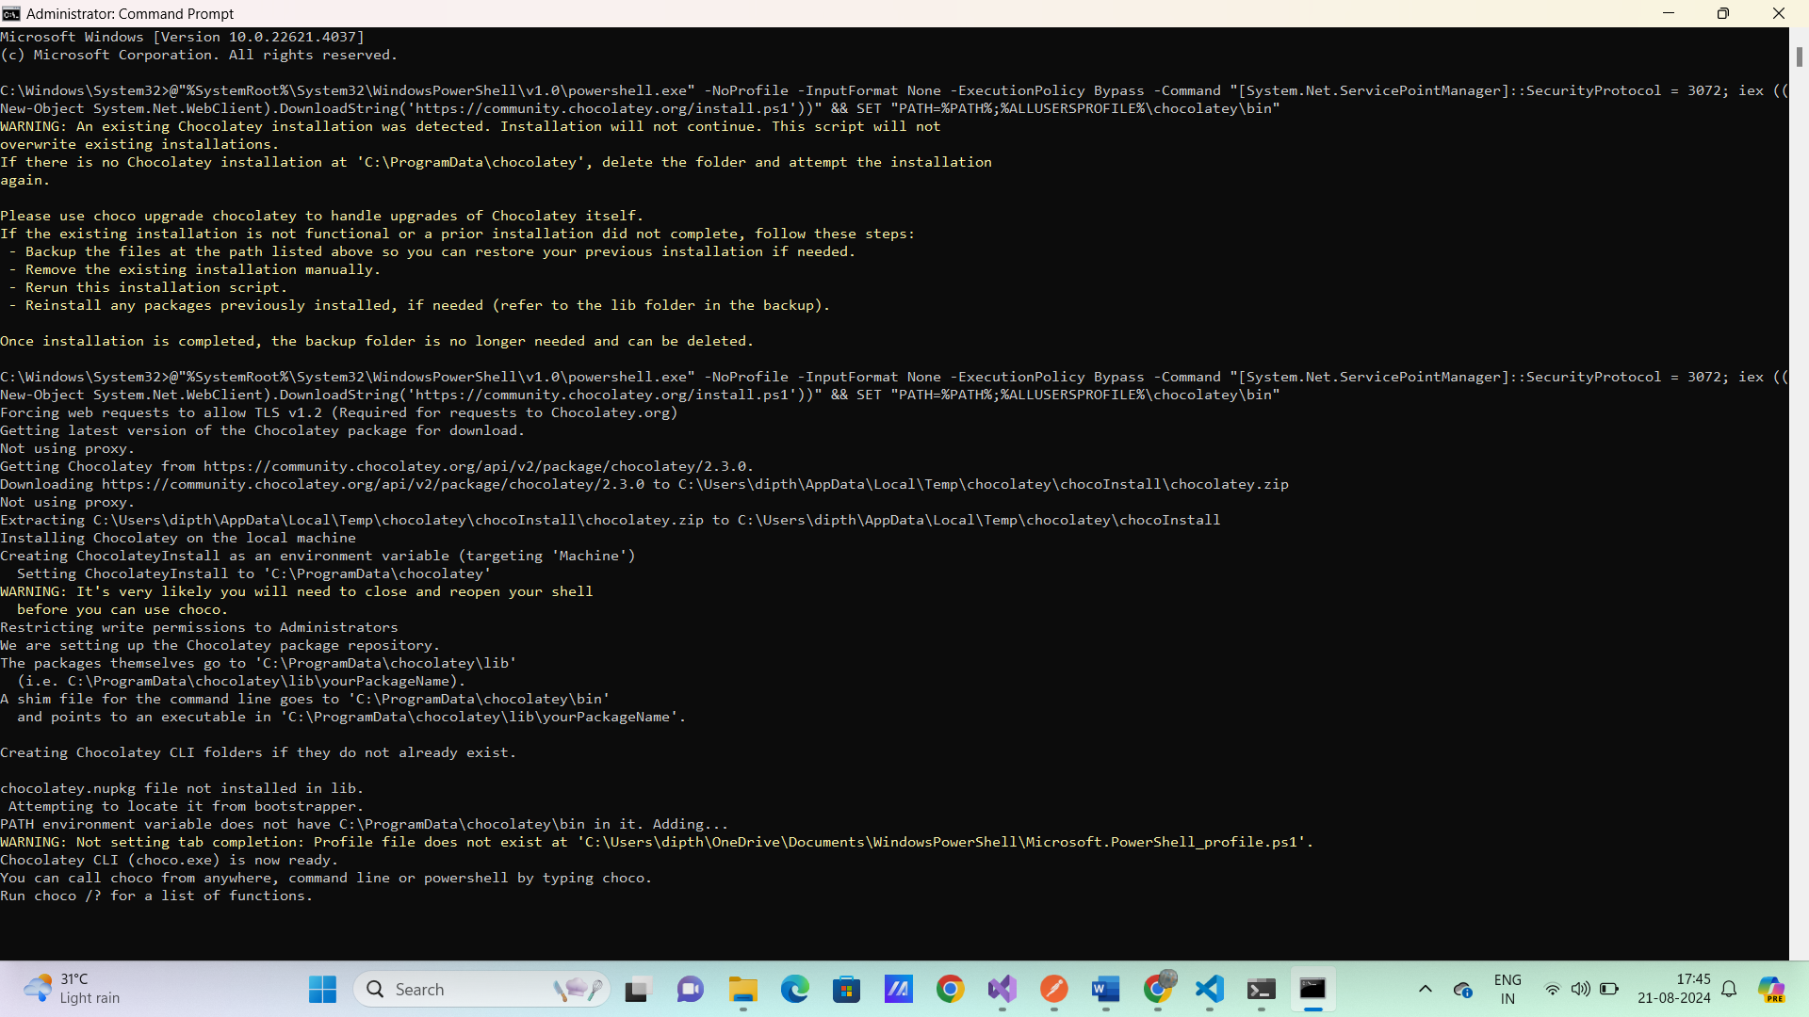

choco install mkcert

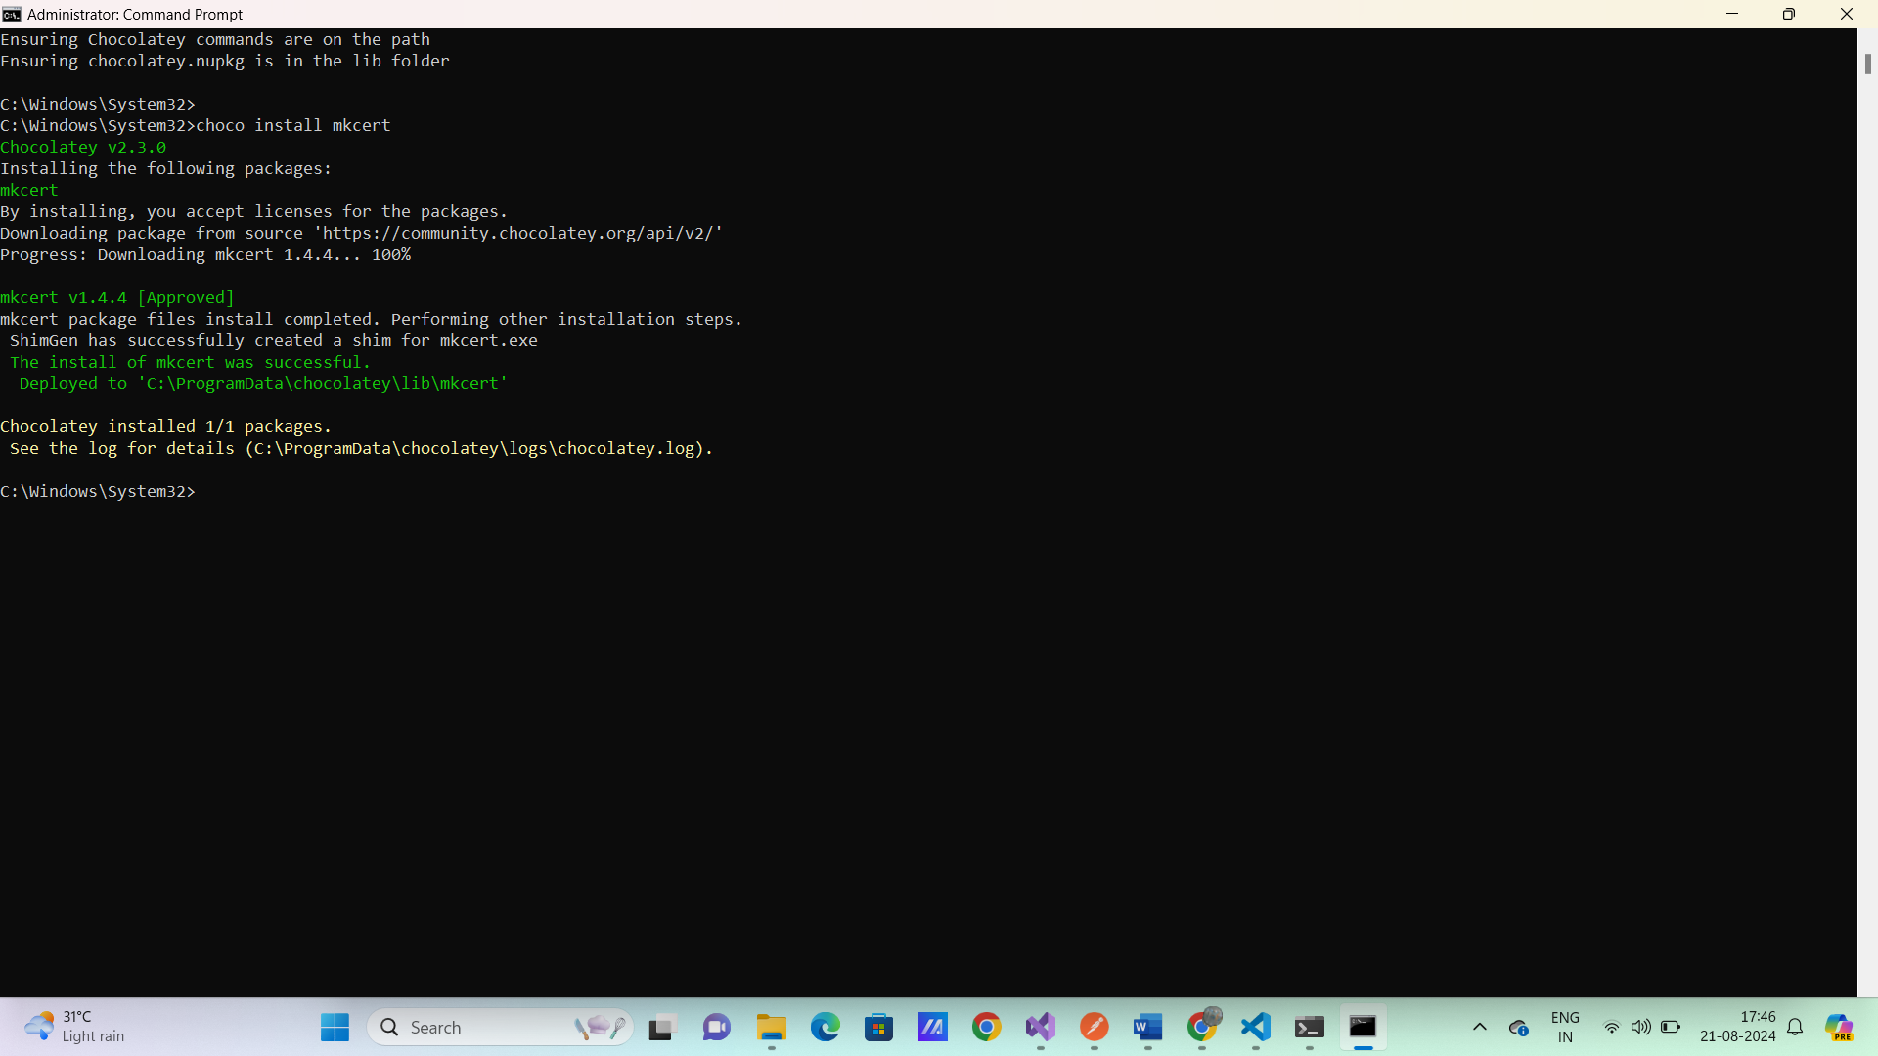

mkcert -install

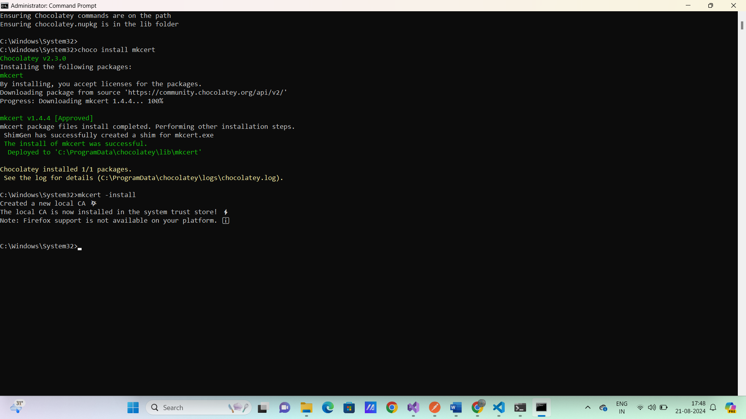

mkdir ssl

mkcert localhost

**Adding Angular Material and Tailwind CSS**

ng add @angular/material

<https://tailwindcss.com/docs/guides/angular>

npm install -D tailwindcss postcss autoprefixer

npx tailwindcss init

**/** @type {import('tailwindcss').Config} */**

**module.exports = {**

**content: [**

**"./src/**/*.{html,ts}",**

**],**

**theme: {**

**extend: {},**

**},**

**plugins: [],**

**}**

styles.scss

**@tailwind base;**

**@tailwind components;**

**@tailwind utilities;**

**Settings.json**

{

    "workbench.colorTheme": "Material Theme",

    "scss.lint.unknownAtRules": "ignore"

}

ng serve

<h1 class="text-3xl font-bold underline">

Hello world!

</h1>

**Adding VS code extension for Angular and Tailwind**

Angular Language Service

Tailwind CSS IntelliSense

Auto Rename Tag

vscode-icons

C# to TypeScript

Redis

**Section 8 - Angular Basics**

Adding Components

Http Client module

Observables

Typescript

ng g c layout/header --dry-run

ng g c layout/header --skip-tests

**styles.scss**

@use '@angular/material' as mat;

$customTheme: mat.define-theme();

@include mat.core();

.custom-theme {

    @include mat.all-component-themes($customTheme);

    //override the button styles

    .mdc-button, .mdc-raised-button, .mdc-stroked-button, .mdc-flat-button {

        @apply rounded-md

    }

}

**index.html**

<html lang="en" class="custom-theme">

**Making Http Request**

**app.config.ts**

export const appConfig: ApplicationConfig = {

  providers: [provideZoneChangeDetection({ eventCoalescing: true }),

    provideRouter(routes),

    provideAnimationsAsync(),

**provideHttpClient(),**

  ]

};

 baseUrl = "https://localhost:7117/api/";

  private http = inject(HttpClient);

 ngOnInit(): void {

      this.http.get<any>(this.baseUrl + 'products').subscribe({

        next: response => this.products = response.data,

        error: error => console.log(error),

        complete:() => console.log('complete')

     });

  }

**Observables**

A sequence of items that arrive asynchronously over time.

|  |  |
| --- | --- |
| Promises | Overvables |
| Has one pipeline | Stream data in multiple pipelines |
| Typically used with async data return | Both async and sync |
| Not easy to cancel | Are Cancellable |
|  | Array like operations |
|  | Can be created from other sources like events |
|  | They can be subscribed to |

**Succeed (Data)**



**Promises**

**---------------------------------------------------------- THEN Fail**

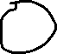

**Observables**

**Cancel**

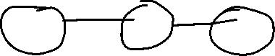

**Fail Succeed Subscribed() map() filter()**

**RxJS**

* Reactive extensions for JavaScript
* Utility library for working with observables, similar to lodash or underscore for JavaScript objects and arrays.
* Uses the pipe() method to chain RxJS operators together.

**TypeScript**

* Strong Typing
* Object Oriented
* Better Intellisense
* Access modifiers
* Future JavaScript features
* Catches silly mistakes in development
* 3rd party libraries
* Easy to learn if you know JS

npx tsc src/demo.ts

node src/demo.js

**Section 9 . Building the User interface for the shop**

* Angular services
* Building the UI for the shop
* Material Components
* Pagination
* Filtering, sorting & Search
* Input properties

ng g s core/services/shop --dry-run

ng g s core/services/shop --skip-tests

ng g c features/shop --skip-tests

ng g c features/shop/product-item --skip-tests

     <p class="font-light">{{product.price | currency }}</p>

import { CurrencyPipe } from '@angular/common';

  imports: [

    MatCard,

    MatCardContent,

    CurrencyPipe

  ],

ng g c features/shop/filters-dialog --skip-tests

<https://fonts.google.com/icons>

Inserting the icon

<span class="material-symbols-outlined">

filter_list

</span>

**ShopComponent**

private diloagService = inject(MatDialog);

  selectedBrands : string[] =[];

  selectedTypes : string[] = [];

 openFilterDialog(){

    const dilogRef = this.diloagService.open(FiltersDialogComponent,{

      minWidth :'500px',

      data:{

        selectedBrands: this.selectedBrands,

        selectedTypes: this.selectedTypes

      }

    });

    dilogRef.afterClosed().subscribe({

      next : result => {

        if(result){

          console.log(result);

          this.selectedBrands = result.selectedBrands;

          this.selectedTypes = result.selectedTypes;

          this.shopService.getProducts(this.selectedBrands,this.selectedTypes).subscribe({

            next: response => this.products = response.data,

            error: error => console.log(error)

          });

        }

      }

    });

  <button mat-stroked-button (click)="openFilterDialog()">

            <mat-icon>filter_list</mat-icon>

        </button>

**FiltersDialogComponent**

  private dialogRef = inject(MatDialogRef<FiltersDialogComponent>);

  data = inject(MAT_DIALOG_DATA);

  selectedBrands : string[] = this.data.selectedBrands;

  selectedTypes : string[] = this.data.selectedTypes;

  applyFilters(){

    this.dialogRef.close({

      selectedBrands: this.selectedBrands ,

      selectedTypes : this.data.selectedTypes

    });

  }

 <div class="flex justify-end p-4">

        <button mat-flat-button (click)="applyFilters()">Apply Filters</button>

    </div>

**ShopService**

  getProducts(brands? : string[] ,types?:string[]){

      let params = new HttpParams();

      if(brands && brands.length > 0){

        params = params.append('brands',brands.join(','));

      }

      if(types && types.length > 0){

        params = params.append('types',types.join(','));

      }

    return this.http.get<Pagination<Product>>(this.baseUrl + 'products',{params});

  }

**Sorting**

 selectedSort :string ='name';

  sortOptions = [

    {name:'Alphabetical',value:'name'},

    {name:'Price: Low-High', value:'priceAsc'},

    {name:'Price: High-Low', value:'priceDesc'}

  ]

  imports: [

    MatCard,

    ProductItemComponent,

    MatIcon,

**MatSelectionList,**

**MatListOption,**

**MatMenuTrigger,**

**MatMenu**

  ],

  <button mat-stroked-button [matMenuTriggerFor]="sortMenu">

            <mat-icon>swap_vert</mat-icon>

            Sort

        </button>

<mat-menu #sortMenu="matMenu">

    <mat-selection-list [multiple]="false" (selectionChange)="onSortChange($event)" >

        @for (sort of sortOptions; track $index) {

            <mat-list-option [value]="sort.value" [selected]="selectedSort === sort.value" >

                {{sort.name}}

            </mat-list-option>

        }

    </mat-selection-list>

</mat-menu>

ngOnInit(): void {

      this.initiallizeShop();

  }

  initiallizeShop(){

    this.shopService.getBrands();

    this.shopService.getTypes();

    this.getProduducts();

  }

  getProduducts(){

    this.shopService.getProducts(this.selectedBrands,this.selectedTypes,this.selectedSort).subscribe({

      next: response => this.products = response.data,

      error: error => console.log(error)

   });

  }

  onSortChange(event : MatSelectionListChange){

    const selectedOption = event.options[0];

    if(selectedOption){

      this.selectedSort = selectedOption.value;

      this.getProduducts();

    }

  }

  openFilterDialog(){

    const dilogRef = this.diloagService.open(FiltersDialogComponent,{

      minWidth :'500px',

      data:{

        selectedBrands: this.selectedBrands,

        selectedTypes: this.selectedTypes

      }

    });

    dilogRef.afterClosed().subscribe({

      next : result => {

        if(result){

          console.log(result);

          this.selectedBrands = result.selectedBrands;

          this.selectedTypes = result.selectedTypes;

         this.getProduducts();

        }

      }

    });

  }

  getProducts(brands? : string[] ,types?:string[],sort? : string){

      let params = new HttpParams();

      if(brands && brands.length > 0){

        params = params.append('brands',brands.join(','));

      }

      if(types && types.length > 0){

        params = params.append('types',types.join(','));

      }

      if(sort){

        params = params.append('sort',sort);

      }

    return this.http.get<Pagination<Product>>(this.baseUrl + 'products',{params});

  }

**Pagination**

export class ShopParams {

    brands : string[] =[];

    type : string[] =[];

    sort = 'name';

    pageNumber = 1;

    pageSize = 1;

    search = ''

}

MatPaginator

products? : Pagination<Product>;

  getProduducts(){

    this.shopService.getProducts(this.shopParams).subscribe({

      next: response => **this.products** = **response**,

      error: error => console.log(error)

   });

  }

  pageSizeOptions = [5,10,15,20];

**shop.service.ts**

    params = params.append('pageSize',shopParams.pageSize);

      params = params.append('pageIndex',shopParams.pageNumber);

  <mat-paginator

            class="bg-white"

            (page)="handlePageEvent($event)"

            [length]="products?.count"

            [pageSize]="shopParams.pageSize"

            [showFirstLastButtons]="true"

            [pageSizeOptions]="pageSizeOptions"

            [pageIndex]="shopParams.pageNumber - 1"

            aria-label="Select Page"

        >

 handlePageEvent(event : PageEvent){

    this.shopParams.pageNumber = event.pageIndex +1 ;

    this.shopParams.pageSize = event.pageSize;

    this.getProduducts();

  }

**Searching**

FormsModule

  onSearchChange(){

    this.shopParams.pageNumber = 1;

    this.getProduducts();

  }

<form #searchForm="ngForm"

            (ngSubmit)="onSearchChange()"

            class="relative flex items-center w-full max-w-md mx-4"

        >

        <input type="search"

            class="block w-full p-4 text-sm text-gray-900 borderborder-gray-300 rounded-lg"

            placeholder="search"

            name="search"

            [(ngModel)]="shopParams.search"

        />

        <button mat-icon-button type="submit" class="absolute inset-y-0 right-8 top-2 flex items-center pl-3">

            <mat-icon>search</mat-icon>

        </button>

        </form>

   if(shopParams.search){

        params = params.append('search',shopParams.search);

      }

**Routing**

app.routes.ts

ng g c features/home --skip-tests

ng g c features/shop/prodcut-details --skip-tests

export const routes: Routes = [

    {path:'',component:HomeComponent},

    {path:'shop',component:ShopComponent},

    {path:'shop/:id',component:ProdcutDetailsComponent},

    {path:'**',redirectTo:'',pathMatch:'full'},

];

<app-header></app-header>

<div class="container mt-6">

    <router-outlet></router-outlet>

</div>

app-header

 RouterLink,

 RouterLinkActive

   <nav class="flex gap-3 my-2 uppercase text-2xl">

            <a routerLink="/" routerLinkActive="active"

            [routerLinkActiveOptions]="{exact : true}"

            >Home</a>

            <a routerLink="/shop" routerLinkActive="active">Shop</a>

            <a routerLink="/shop">Contact</a>

        </nav>

a {

    &.active {

        color: #7d00fa;

    }

}

  private shopService = inject(ShopService);

  private activatedRoute = inject(ActivatedRoute);

  loadProduct(){

    const id = this.activatedRoute.snapshot.paramMap.get('id');

    if(!id) return;

    this.shopService.getProdcut(+id).subscribe({

      next:product => this.product = product,

      error: error => console.log(error)

    })

  }

.product-card{

    transition: transform .02s, box-shadow 0.2s;

}

.product-card:hover {

    transform: translate(-10px);

    box-shadow: 0 4px 8px rgba(0,0,0,0.2);

}

@if (product) {

    <mat-card appearance="raised" routerLink="/shop/{{product.id}}" class="product-card">

        <img src="{{product.pictureUrl}}" alt="image of {{product.name}}" >

        <mat-card-content class="mt-2">

            <h2 class="text-sm font-semibold uppercase"> {{product.name}}</h2>

            <p class="font-light">{{product.price | currency }}</p>

        </mat-card-content>

        <mat-card-actions>

            <button mat-stroked-button class="w-full">

                <mat-icon>add_shopping_cart</mat-icon>

                Add to Cart

            </button>

        </mat-card-actions>

    </mat-card>

}

**Section 11 . Client Error Handling and loading**

* Http interceptors
* Adding toast notifications
* Adding loading notifications

ng g c shared/components/not-found --skip-tests

ng g c shared/components/server-error --skip-tests

export const routes: Routes = [

    {path:'',component:HomeComponent},

    {path:'shop',component:ShopComponent},

    {path:'shop/:id',component:ProdcutDetailsComponent},

    {path:'not-found',component:NotFoundComponent},

    {path:'server-error',component:ServerErrorComponent},

    {path:'**',redirectTo:'not-found',pathMatch:'full'},

];

HTTP Interceptor for Handling API errors

ng g interceptor core/interceptors/error --skip-tests

export const errorInterceptor: HttpInterceptorFn = (req, next) => {

  const router = inject(Router);

  const snackbar = inject(SnackbarService);

  return next(req).pipe(

    catchError((err: HttpErrorResponse ) => {

      if(err.status === 400){

        snackbar.error(err.error.title || err.error)

      }

      if(err.status === 401){

        snackbar.error(err.error.title || err.error)

      }

      if(err.status === 404){

        router.navigateByUrl('/not-found');

      }

      if(err.status === 500){

        router.navigateByUrl('/server-error');

      }

      return throwError(()=> err);

    })

  )

};

app.config.ts

export const appConfig: ApplicationConfig = {

  providers: [provideZoneChangeDetection({ eventCoalescing: true }),

    provideRouter(routes),

    provideAnimationsAsync(),

**provideHttpClient(withInterceptors([errorInterceptor])),**

  ]

};

Adding Toast – Snackbar

ng g s core/services/snackbar --skip-tests

export class SnackbarService {

  private snackbar = inject(MatSnackBar);

  error(message : string){

    this.snackbar.open(message,'Close',{

      duration:5000,

      panelClass:['snack-error']

    })

  }

  success(message : string){

    this.snackbar.open(message,'Close',{

      duration:5000,

      panelClass:['snack-success']

    })

  }

}

  if(err.status === 400){

        if(err.error.errors){

          const modelStateErrors = [];

          for(const key in err.error.errors){

            if(err.error.errors[key]){

              modelStateErrors.push(err.error.errors[key])

            }

          }

          throw modelStateErrors.flat();

        }else{

          snackbar.error(err.error.title || err.error)

        }

      }

     if(err.status === 500){

        const navigationExtras : NavigationExtras = {state: {error:err.error}}

        router.navigateByUrl('/server-error',navigationExtras);

      }

ServerErrorComponent

    error?: HttpErrorResponse;

    constructor(private router : Router) {

      const navigation = this.router.getCurrentNavigation();

      this.error = navigation?.extras.state?.['error'];

    }

Http Loading Interceptor

ng g interceptor core/interceptors/loading --skip-tests

    provideHttpClient(withInterceptors([errorInterceptor,loadingInterceptor])),

ng g s core/services/busy --skip-tests

export class BusyService {

  loading = false;

  busyRequestCount = 0;

  busy(){

    this.busyRequestCount++;

    this.loading = true;

  }

  idle (){

    this.busyRequestCount--;

    if(this.busyRequestCount <= 0){

      this.busyRequestCount =0;

      this.loading = false;

    }

  }

}

export const loadingInterceptor: HttpInterceptorFn = (req, next) => {

  const busyService = inject(BusyService);

  busyService.busy();

  return next(req).pipe(

    finalize(() => busyService.idle())

  );

};

**HeaderComponent**

@if(busyService.loading){

    <mat-progress-bar mode="indeterminate" class="fixed top-20 z-50">

    </mat-progress-bar>

}

  busyService = inject(BusyService);

**Section 12 – API- Shopping cart**

* Adding Redis to the API
* Creating the cart service & controller
* **Where to store the basket? : / Where to ‘store’ the cart :**
* Database
* Local Storage (client side)
* Cookie
* **Redis**
* **Redis** – In-memory data structure store
* Supporting strings,hashes,list,sets,etc
* Key/value store
* Fast
* Persists data by using snapshots every minute
* Data can be given time to live
* Great for caching data

Creating a Redis Instance

docker version

docker compose down

docker compose up -d

<https://redis.io/docs/latest/operate/oss_and_stack/install/install-redis/install-redis-on-windows/>

# How to install Linux on Windows with WSL

wsl --install

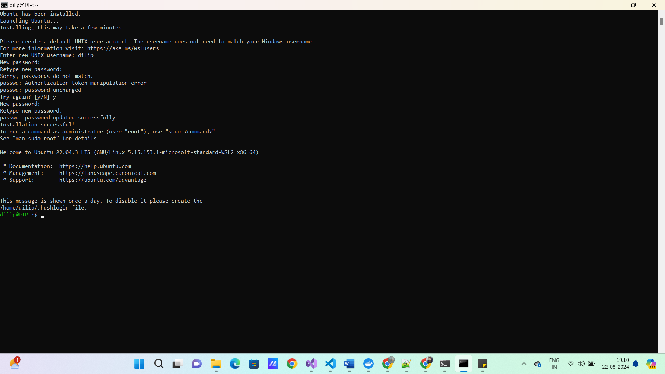

curl -fsSL https://packages.redis.io/gpg | sudo gpg --dearmor -o /usr/share/keyrings/redis-archive-keyring.gpg

echo "deb [signed-by=/usr/share/keyrings/redis-archive-keyring.gpg] https://packages.redis.io/deb $(lsb_release -cs) main" | sudo tee /etc/apt/sources.list.d/redis.list

sudo apt-get update

sudo apt-get install redis

redis-server

start ubntu.exe

sudo service redis-server start

redis-cli

127.0.0.1:6379> ping

PONG

KEYS *

Infrastructure - project

**StackExchange.Redis**

builder.Services.AddSingleton<IConnectionMultiplexer>(config =>

{

var connString = builder.Configuration.GetConnectionString("redis") ?? throw new Exception("Cannot get redis connection string");

var configuration = ConfigurationOptions.Parse(connString,true);

return ConnectionMultiplexer.Connect(configuration);

});

"ConnectionStrings": {

"DefaultConnection": "Server=DIP;Database=skinet;Trusted_Connection=True;TrustServerCertificate=True",

**"Redis": "localhost"**

}

namespace Core.Entities

{

public class ShoppingCart

{

public required string Id { get; set; }

public List<CartItem> Items { get; set; } = [];

}

}

namespace Core.Entities

{

public class CartItem

{

public int ProducId { get; set; }

public required string Productname { get; set; }

public decimal Price { get; set; }

public int Quantity { get; set; }

public required string PictureUrl { get; set; }

public required string Brand { get; set; }

public required string Type { get; set; }

}

}

namespace Core.Interfaces

{

public interface ICartService

{

Task<ShoppingCart?> GetCartAsync(string key);

Task<ShoppingCart?> SetCartAsync(ShoppingCart cart);

Task<bool> DeleteCartAsync(string key);

}

}

namespace Infrastructure.Services

{

public class CartService(IConnectionMultiplexer redis) : ICartService

{

private readonly IDatabase _database = redis.GetDatabase();

public async Task<bool> DeleteCartAsync(string key)

{

return await _database.KeyDeleteAsync(key);

}

public async Task<ShoppingCart?> GetCartAsync(string key)

{

var data = await _database.StringGetAsync(key);

return data.IsNullOrEmpty ? null : JsonSerializer.Deserialize<ShoppingCart?>(data!);

}

public async Task<ShoppingCart?> SetCartAsync(ShoppingCart cart)

{

var created = await _database.StringSetAsync(cart.Id,JsonSerializer.Serialize(cart),TimeSpan.FromDays(30));

if (!created) return null;

return await GetCartAsync(cart.Id);

}

}

}

builder.Services.AddSingleton<ICartService,CartService>();

namespace API.Controllers

{

public class CartController(ICartService cartService) : BaseApiController

{

[HttpGet]

public async Task<ActionResult<ShoppingCart>> GetCartById(string id)

{

var cart = await cartService.GetCartAsync(id);

return Ok(cart ?? new ShoppingCart { Id =id });

}

[HttpPost]

public async Task<ActionResult<ShoppingCart>> UpdateCart(ShoppingCart cart)

{

var updatedCart = await cartService.SetCartAsync(cart);

if (updatedCart == null) return BadRequest("Problem with cart");

return updatedCart;

}

[HttpDelete]

public async Task<ActionResult> DeleteCart(string id)

{

var result = await cartService.DeleteCartAsync(id);

if (!result) return BadRequest("Problem Deleting cart");

return Ok();

}

}

}

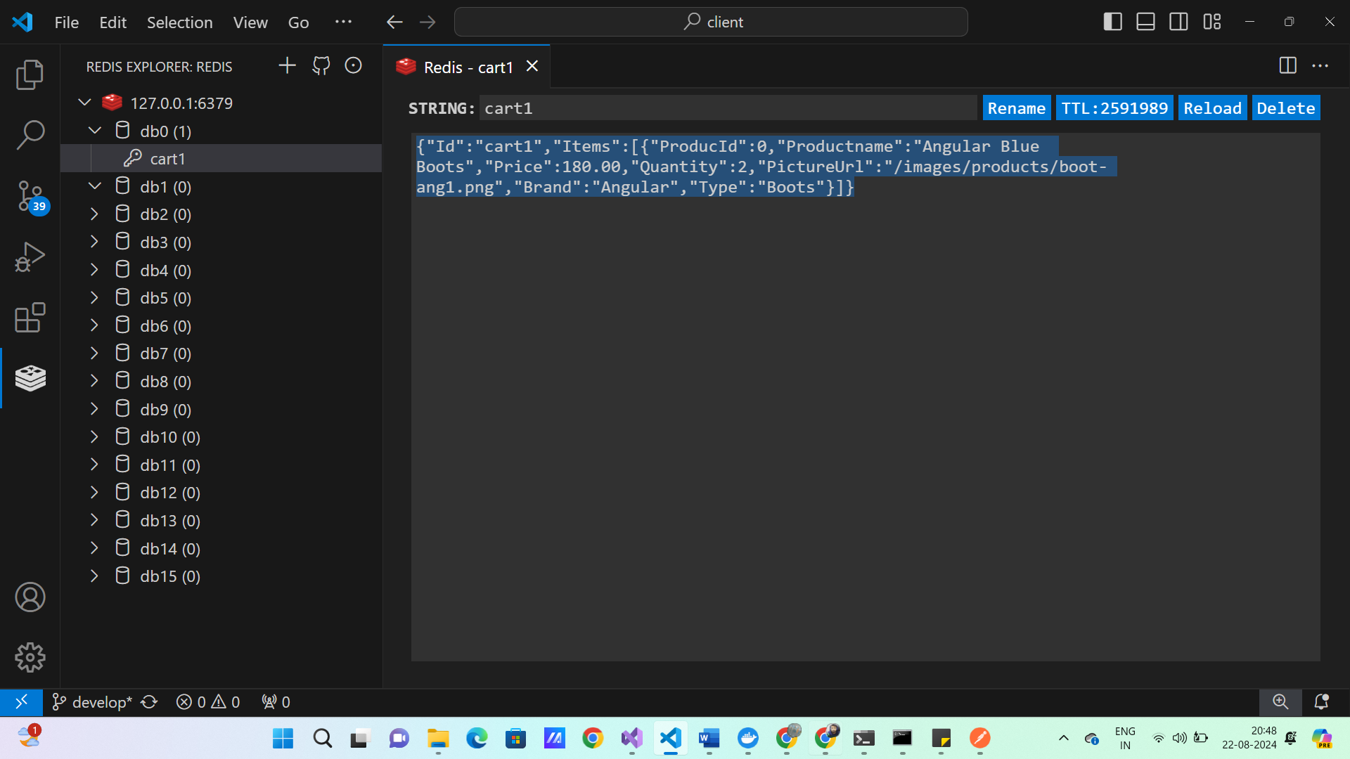

Section -13 . Client Shopping Cart

* Angular signals
* Environment variables

ng g s core/services/cart --skip-tests

ng g c features/cart --skip-tests

npm install nanoid

import { nanoid } from 'nanoid'

export class Cart implements CartType {

    id = nanoid();

    items : CartItem[] = [];

}

Angular Signals

* State that can be observed and reacted to
* Clean API for state management
* Avoid the complexity of observable

**Signal ---🡪 Computed ---🡪 Effect**

const count = signal(0)

**//Get Singal value**

console.log(count())

**//Set a new value**

count.set(3)

**//Update a value**

count.update(value => value +2)

ng g environments

export const environment = {

    production : false,

    apiUrl :'api/'

};

export class CartService {

  baseUrl = environment.apiUrl;

  private http = inject(HttpClient);

  cart = signal<Cart | null>(null);

  getCart(id : string){

    return this.http.get<Cart>(this.baseUrl + 'cart?id='+id).subscribe({

      next: cart => this.cart.set(cart)

    });

  }

  setCart(cart : Cart){

    return this.http.post<Cart>(this.baseUrl + 'cart',cart).subscribe({

      next:cart => this.cart.set(cart)

    })

  }

  addItemToCart(item : CartItem | Product, quantity = 1){

    const cart = this.cart() ?? this.createCart();

    if(this.isProduct(item)){

      item = this.mapProductToCartItem(item);

    }

    cart.items = this.addOrUdpateItems(cart.items,item,quantity);

    this.setCart(cart)

  }

  addOrUdpateItems(items: CartItem[], item: CartItem, quantity: number): CartItem[] {

    const index = items.findIndex(x=>x.producId == item.producId);

    if(index === -1){

      item.quantity = quantity;

      items.push(item);

    }else{

      items[index].quantity += quantity;

    }

    return items;

  }

  mapProductToCartItem(item: Product): CartItem {

    return {

      producId: item.id,

      productname: item.name,

      price: item.price,

      quantity:0,

      pictureUrl:item.pictureUrl,

      brand:item.brand,

      type:item.type

    }

  }

  private isProduct(item : CartItem | Product): item is Product{

    return (item as Product).id !== undefined;

  }

  private createCart(): Cart {

    const cart = new Cart();

    localStorage.setItem('cart_id',cart.id);

    return cart;

    }

}

 <mat-card-actions **(click)="$event.stopPropagation()">**

            <button mat-stroked-button class="w-full" (click)="carService.addItemToCart(product)">

                <mat-icon>add_shopping_cart</mat-icon>

                Add to Cart

            </button>

        </mat-card-actions>

**Persisting the cart**

ng g s core/services/init --skip-tests

getCart(id : string){

    return this.http.get<Cart>(this.baseUrl + 'cart?id='+id).pipe(

      map(cart =>  {

        this.cart.set(cart);

        return cart;

      })

    );

  }

export class InitService {

    private cartService  = inject(CartService);

    init(){

      const cartId = localStorage.getItem('cart_id');

      const cart$ = cartId ? this.cartService.getCart(cartId) : of(null);

      return cart$;

    }

}

**app.config.ts**

function initializeApp(initService : InitService){

  return () => lastValueFrom(initService.init()).finally(() => {

      const splash= document.getElementById('initial-splash');

      if(splash){

        splash.remove();

      }

  })

}

export const appConfig: ApplicationConfig = {

  providers: [provideZoneChangeDetection({ eventCoalescing: true }),

    provideRouter(routes),

    provideAnimationsAsync(),

    provideHttpClient(withInterceptors([errorInterceptor,loadingInterceptor])),

**{      provide:APP_INITIALIZER,**

**useFactory:initializeApp,**

**multi:true,**

**deps:[InitService]**

**}**

  ]

};

**Index.html**

<body>

**<div id="initial-splash">**

**<div class="flex items-center justify-center h-screen">**

**<div class="flex-col items-center align-middle">**

**<img src="../images/logo.png" alt="logo">**

**</div>**

**</div>**

**</div>**

  <app-root></app-root>

</body>

**CartService**

 itemCount = computed(() =>{

    return this.cart()?.items.reduce((sum,item)=> sum + item.quantity, 0)

  })

ng g c features/cart/cart-item --skip-tests

ng g c shared/components/order-summary --skip-tests

  totals = computed(()=> {

    const cart = this.cart();

    if(!cart) return null;

    const subtotal = cart.items.reduce((sum,item)=> sum + item.price * item.quantity,0);

    const shipping = 0;

    const discount = 0;

    return {

      subtotal,

      shipping,

      discount,

      total : subtotal + shipping - discount

    }

  })

**CartService**

  removeItemFromCart(producId : number,quantity = 1){

    const cart = this.cart();

    if(!cart) return;

    const index = cart.items.findIndex(x => x.producId === producId);

    if(index !== -1){

      if(cart.items[index].quantity > quantity){

        cart.items[index].quantity -= quantity;

      }else{

        cart.items.splice(index,1);

      }

      if(cart.items.length === 0){

        this.deleteCart();

      }else{

        this.setCart(cart);

      }

    }

  }

  deleteCart() {

   this.http.delete(this.baseUrl +'cart?id=' + this.cart()?.id).subscribe({

    next:() => {

      localStorage.removeItem('cart_id');

      this.cart.set(null);

    }

   })

  }

export class CartItemComponent {

  item  = input.required<CartItem>();

  cartService = inject(CartService);

  incrementQuantity(){

    this.cartService.addItemToCart(this.item());

  }

  decrementQuantity(){

    this.cartService.removeItemFromCart(this.item().producId);

  }

  removeItemFromCart(){

    this.cartService.removeItemFromCart(this.item().producId,this.item().quantity);

  }

}

ng g s core/services/checkout --skip-tests

ng g c features/checout --skip-tests

**Section 14 . API Identity**

* Setting up ASP.NET Identity
* Using the UserManager & SignInManager
* Claims
* Extension methods

**Storing user accounts in the app – why do it ?**

* Full control
* Customization
* No dependencies
* Cost
* Security risks
* Compliance
* Overhead

.Net Identity API Endpoints

The **MapIdentityApi<TUser>** endpoints

* POST/register
* POST/login
* POST/refresh
* GET/confirmEmail
* POST/ resendConfirmationEmail
* POST/forgotPassword
* POST/resetPassword
* POST/manage/2fa
* GET/manage/info
* POST/manage/info

**Setting up Identity**

**Infrastructure**

Microsoft.Extensions.Identity.Stores

Microsoft.AspNetCore.Identity.EntityFramework

namespace Core.Entities

{

public class AppUser : IdentityUser

{

public string? FirstName { get; set; }

public string? LastName { get; set; }

}

}

public class StoreContext(DbContextOptions options) : **IdentityDbContext<AppUser>(options)**

{

}

**Program.cs**

builder.Services.AddIdentityApiEndpoints<AppUser>().AddEntityFrameworkStores<StoreContext>();

**app.MapGroup("api").MapIdentityApi<AppUser>(); // api/login**

Infrastructure

add-migration identity

update-database

namespace API.DTOs

{

public class RegisterDto

{

[Required]

public string FirstName { get; set; } = string.Empty;

[Required]

public string LastName { get; set; } = string.Empty;

[Required]

public string Email { get; set; } = string.Empty;

[Required]

public string Password { get; set; } = string.Empty;

}

}

namespace API.Controllers

{

public class AccountController(SignInManager<AppUser> signInManager) : BaseApiController

{

[HttpPost("register")]

public async Task<ActionResult> Register(RegisterDto registerDto)

{

var user = new AppUser

{

FirstName = registerDto.FirstName,

LastName = registerDto.LastName,

Email = registerDto.Email,

UserName = registerDto.Email

};

var result = await signInManager.UserManager.CreateAsync(user,registerDto.Password);

if(!result.Succeeded) return BadRequest(result.Errors);

return Ok(result);

}

}

}

[Authorize]

[HttpPost("logout")]

public async Task<ActionResult> Logout()

{

await signInManager.SignOutAsync();

return NoContent();

}

[HttpGet("user-info")]

public async Task<ActionResult> GetUserInfo()

{

if (User.Identity?.IsAuthenticated == false) return NoContent();

var user = await signInManager.UserManager.Users.

FirstOrDefaultAsync(x => x.Email == User.FindFirstValue(ClaimTypes.Email));

if(user == null) return Unauthorized();

return Ok(new

{

user.FirstName,

user.LastName,

user.Email

});

}

[HttpGet]

public ActionResult GetAuthState()

{

return Ok(new { IsAuthenticated = User.Identity?.IsAuthenticated ?? false });

}

namespace API.Extensions

{

public static class ClaimsPrincipaleExtensions

{

public static async Task<AppUser> GetUserByEmail(this UserManager<AppUser> userManager,ClaimsPrincipal user)

{

var userToReturn = await userManager.Users.FirstOrDefaultAsync(x => x.Email == user.GetEmail()) ?? throw new AuthenticationException("User not Found");

return userToReturn;

}

public static string GetEmail(this ClaimsPrincipal user)

{

var email = user.FindFirstValue(ClaimTypes.Email) ?? throw new AuthenticationException("Email claim not found");

return email;

}

}

}

[HttpGet("user-info")]

public async Task<ActionResult> GetUserInfo()

{

if (User.Identity?.IsAuthenticated == false) return NoContent();

var user = await signInManager.UserManager.GetUserByEmail(User);

return Ok(new

{

user.FirstName,

user.LastName,

user.Email

});

}

Validation errors in Identity

[HttpPost("register")]

public async Task<ActionResult> Register(RegisterDto registerDto)

{

var user = new AppUser

{

FirstName = registerDto.FirstName,

LastName = registerDto.LastName,

Email = registerDto.Email,

UserName = registerDto.Email

};

var result = await signInManager.UserManager.CreateAsync(user,registerDto.Password);

if(!result.Succeeded)

{

**foreach (var error in result.Errors)**

**{**

**ModelState.AddModelError(error.Code, error.Description);**

**}**

**return ValidationProblem();**

}

return Ok(result);

}

**Add Address to User**

namespace Core.Entities

{

public class Address : BaseEntity

{

public string Line1 { get; set; }

public string? Line2 { get; set; }

public string City { get; set; }

public string State { get; set; }

public string PostalCode { get; set; }

public string Country { get; set; }

}

}

namespace Core.Entities

{

public class AppUser : IdentityUser

{

public string? FirstName { get; set; }

public string? LastName { get; set; }

**public Address? Address { get; set; }**

}

}

public DbSet<Address> Addresses { get; set; }

add-migration addressAdded

update-database

public static async Task<AppUser> GetUserByEmailWithAddress(this UserManager<AppUser> userManager, ClaimsPrincipal user)

{

var userToReturn = await userManager.Users.Include(x=>x.Address)

.FirstOrDefaultAsync(x => x.Email == user.GetEmail());

if(userToReturn == null) throw new AuthenticationException("User not Found");

return userToReturn;

}

namespace API.Extensions

{

public static class AddressMappingExtentions

{

public static AddressDto ToDto(this Address? address)

{

if (address == null) throw new ArgumentNullException(nameof(address));

return new AddressDto

{

Line1 = address.Line1,

Line2 = address.Line2,

City = address.City,

State = address.State,

Country = address.Country,

PostalCode = address.PostalCode,

};

}

public static Address ToEntity(this AddressDto addressDto)

{

if (addressDto == null) throw new ArgumentNullException(nameof(addressDto));

return new Address

{

Line1 = addressDto.Line1,

Line2 = addressDto.Line2,

City = addressDto.City,

State = addressDto.State,

Country = addressDto.Country,

PostalCode = addressDto.PostalCode,

};

}

public static void UpdateFromDto(this Address address, AddressDto addressDto)

{

if (addressDto == null) throw new ArgumentNullException(nameof(addressDto));

if (address == null) throw new ArgumentNullException(nameof(address));

address. Line1 = addressDto.Line1;

address. Line2 = addressDto.Line2;

address. City = addressDto.City;

address. State = addressDto.State;

address. Country = addressDto.Country;

address. PostalCode = addressDto.PostalCode;

}

}

}

[Authorize]

[HttpPost("address")]

public async Task<ActionResult<Address>> CreateOrUpdateAddress(AddressDto addressDto)

{

var user = await signInManager.UserManager.GetUserByEmailWithAddress(User);

if (user.Address == null)

{

user.Address = addressDto.ToEntity();

}

else

{

user.Address.UpdateFromDto(addressDto);

}

var restult = await signInManager.UserManager.UpdateAsync(user);

if (!restult.Succeeded) return BadRequest("Problem updating user address");

return Ok(user.Address.ToDto());

}

[HttpGet("user-info")]

public async Task<ActionResult> GetUserInfo()

{

if (User.Identity?.IsAuthenticated == false) return NoContent();

var user = await signInManager.UserManager.**GetUserByEmailWithAddress** (User);

return Ok(new

{

user.FirstName,

user.LastName,

user.Email,

**Address = user.Address.ToDto()**

});

}

app.UseCors(x=>x.AllowAnyHeader().AllowAnyMethod().**AllowCredentials()**

.WithOrigins("http://localhost:4200","https://localhost:4200"));

**Section 15 – Client Identity**

* Adding an account feature
* Forms in Angular
* Reactive Forms
* Reusable form components
* Client side validation

ng g s core/services/account --skip-tests

ng g c features/account/register --skip-tests

ng g c features/account/login --skip-tests

**user.ts**

export type User =  {

    firstName: string;

    lastName: string;

    email:string;

    address: Address;

}

export type Address = {

    line1 : string;

    line2? : string;

    city : string;

    state : string;

    country:string;

    postalCode:string;

}

export class AccountService {

  baseUrl = environment.apiUrl;

  private http = inject(HttpClient)

  currentUser = signal<User | null>(null);

  login(values :any){

    let params = new HttpParams();

    params = params.append('useCookies',true);

    return this.http.post<User>(this.baseUrl + 'login', values , {params });

  }

  register(values : any){

    return this.http.post(this.baseUrl + 'account/register',values);

  }

  getUserInfo(){

    return this.http.get<User>(this.baseUrl + 'account/user-info').subscribe({

      next : user => this.currentUser.set(user)

    })

  }

  logout(){

    return this.http.post(this.baseUrl + 'account/logout',{});

  }

  udpateAddress(address : Address){

    return this.http.post(this.baseUrl + 'account/address',address);

  }

}

**Angular Forms**

FormsModule – Template-driven

ReactiveFormsModule – Reactive

**FormsModule – Template-driven**

* Easy to use
* 2 way binding
* NgModel directive
* Minimal component code
* Automatic tracking by angular
* Testing is difficult

**ReactiveFormsModule – Reactive**

* Flexible
* Immutable data model
* Uses observable operators
* More component code
* Easier to test
* Reactive transformations (debounce)

**Building blocks of Forms**

* FormControl
* FormGroup
* FormArray

**LoginComponent**

  private  fb = inject(FormBuilder);

 loginForm = this.fb.group({

  });

<mat-card class="max-w-lg mx-auto mt-32 p-8 bg-white">

    <form **[formGroup]="loginForm" (ngSubmit)="onSubmit()"**>

        <div class="text-center nb-6">

            <h1 class="text-3xl font-semibold text-primary">Login</h1>

        </div>

        <mat-form-field appearance="outline"  class="w-full mb-4">

            <mat-label>Email Address</mat-label>

            <input type="email" **formControlName="email"** placeholder="d@d.com" matInput />

        </mat-form-field>

        <mat-form-field appearance="outline"  class="w-full mb-4">

            <mat-label>Password</mat-label>

            <input type="password" **formControlName="password"** placeholder="Password" matInput />

        </mat-form-field>

        <button mat-flat-button **type="submit"** class="w-full py-2">Sign in</button>

    </form>

</mat-card>

**Persisting the Login**

  getUserInfo(){

    return this.http.get<User>(this.baseUrl + 'account/user-info').pipe(

      map(user => {

        this.currentUser.set(user)

        return user;

      })

    )

    }

export class InitService {

    private cartService  = inject(CartService);

**private accountService  = inject(AccountService);**

    init(){

      const cartId = localStorage.getItem('cart_id');

      const cart$ = cartId ? this.cartService.getCart(cartId) : of(null);

**return forkJoin({**

        cart: cart$,

**user:this.accountService.getUserInfo()**

**});**

    }

}

**Auth Interceptor**

ng g interceptor core/interceptors/auth --skip-tests

provideHttpClient(withInterceptors([

      errorInterceptor,

      loadingInterceptor,

**authInterceptor**

    ])),

JsonPipe

<mat-card class="max-w-lg mx-auto mt-3 p-2">

    <pre>Form values : {{ registerForm.value | json}}</pre>

</mat-card>

ng g c shared/components/text-input --skip-tests

<mat-form-field appearance="outline"  class="w-full mb-4">

    <mat-label>{{label}}</mat-label>

    <input type="{{type}}" [formControl]="control" placeholder="{{label}}" matInput />

   @if (control.hasError('required')) {

        <mat-error>{{label}} is required. </mat-error>

    }

    @if (control.hasError('email')) {

        <mat-error>Email is invalid. </mat-error>

    }

</mat-form-field>

export class TextInputComponent implements ControlValueAccessor{

  @Input() label = '';

  @Input() type = 'text';

  constructor(@Self() public controlDir : NgControl){

      this.controlDir.valueAccessor = this;

  }

  get control(){

    return this.controlDir.control as FormControl;

  }

}

<mat-card class="max-w-lg mx-auto mt-32 p-8 bg-white">

    <form [formGroup]="registerForm" (ngSubmit)="onSubmit()">

        <div class="text-center mb-6">

            <h1 class="text-3xl font-semibold text-primary">Register</h1>

        </div>

        <app-text-input label="First Name" formControlName="firstName" />

        <app-text-input label="Last Name" formControlName="lastName" />

        <app-text-input label="Email Address" formControlName="email" type="email"/>

        <app-text-input label="Password" formControlName="password" type="password" />

        @if (validationErrors) {

            <div class="mb-3 p-4 bg-red-100 text-red-600">

                <ul class="list-disc px-3">

                    @for (error of validationErrors; track $index) {

                        <li>{{error}}</li>

                    }

                </ul>

            </div>

        }

        <button

            [disabled]="registerForm.invalid"

             mat-flat-button

             type="submit"

             class="w-full py-2">Register</button>

    </form>

</mat-card>

ng g g core/guards/auth --skip-tests

import { inject } from '@angular/core';

import { CanActivateFn, Router } from '@angular/router';

import { AccountService } from '../services/account.service';

import { inject } from '@angular/core';

import { CanActivateFn, Router } from '@angular/router';

import { AccountService } from '../services/account.service';

import { map, of } from 'rxjs';

export const authGuard: CanActivateFn = (route, state) => {

  const accountService = inject(AccountService);

  const router = inject(Router);

  if(accountService.currentUser()){

    return of(true);

  }else{

    return accountService.getAuthState().pipe(

      map(auth => {

        if(auth.isAuthenticated){

          return true;

        }else{

          router.navigate(['/account/login'],{queryParams: {returnUrl: state.url}});

          return false;

        }

      })

    )

  }

};

getAuthState(){

    return this.http.get<{isAuthenticated : boolean}>(this.baseUrl + 'account/auth-status');

  }